Web Technology - Lab

Submitted By:
Sr# | Name | Section | Roll Number | Semester
1 | Hafiz Muhammad Hamza Khalid | G | Fa2023-BSCS/283 | 5th

Submitted To:
___________________ (Signature)
Muhammad Yousaf


Department Of Computer Science
Lahore Garrison University
Lahore

Step 1: Inspect HTTP Requests with DevTools
1. Open any simple HTML page (e.g., index.html) using Live Server.
2. Right-click → Inspect → go to Network tab.
3. Reload the page (F5) to capture network activity.
4. Click on the main request (e.g., index.html) and observe:
- Request Method (GET)
- Status Code (e.g., 200 OK)
- Request Headers (Host, User-Agent)
- Response Headers (Content-Type, Cache-Control) Screenshot Tip: Capture the headers and status code view.

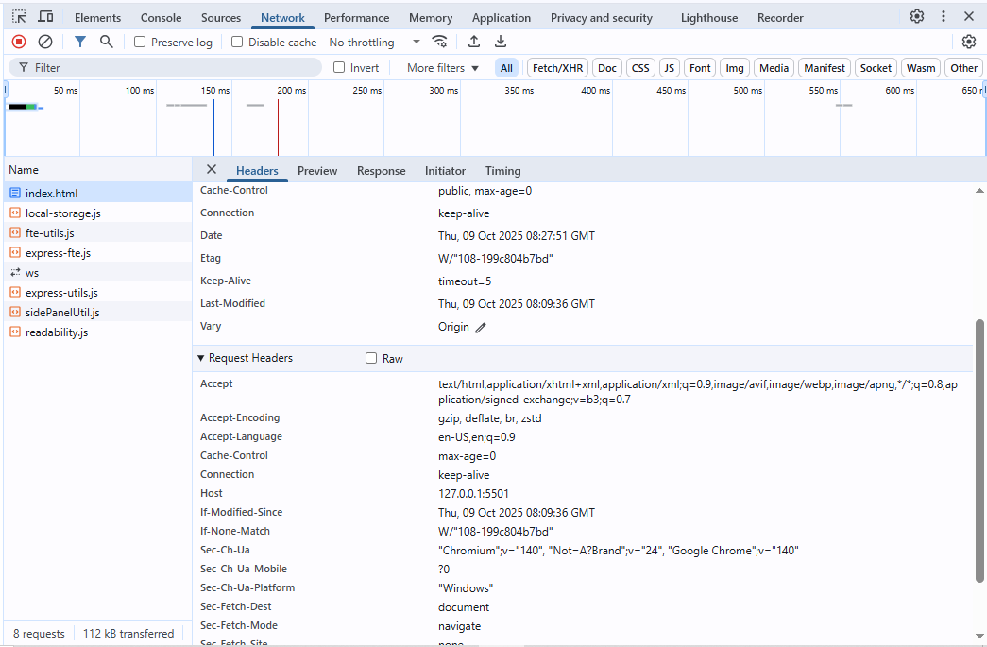
Step 2: Make GET/POST Requests with Postman or curl Using Postman
1. Open Postman and create a GET request to your local server (e.g., http://localhost:5500/index.html).
2. Observe the status code, response body, and headers.
3. Create a POST request to a test endpoint (e.g., https://httpbin.org/post).
- Add a JSON body: { o "name": "Student", o "lab": "HTTP Basics" o }
- Send the request and inspect the response. Using curl (optional) curl -X POST

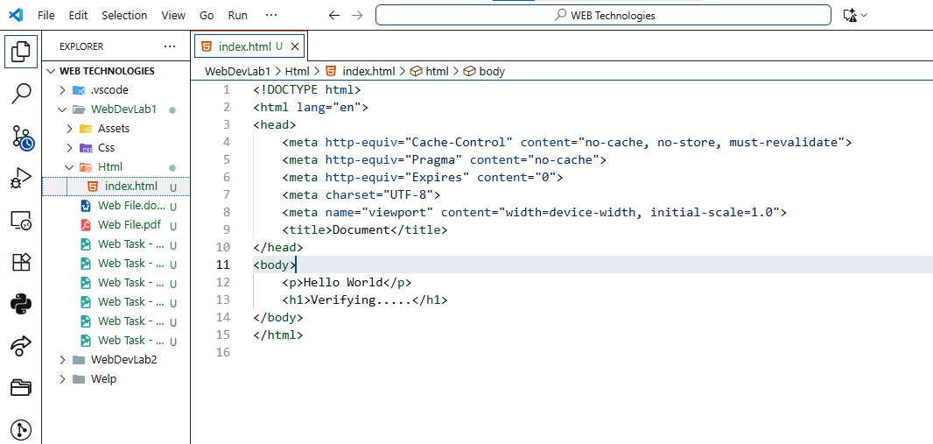
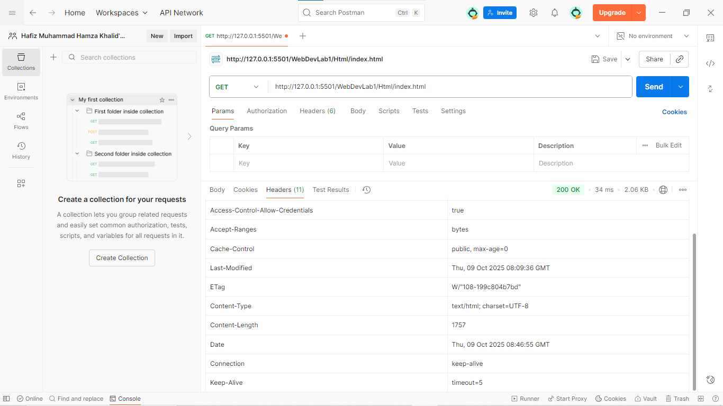
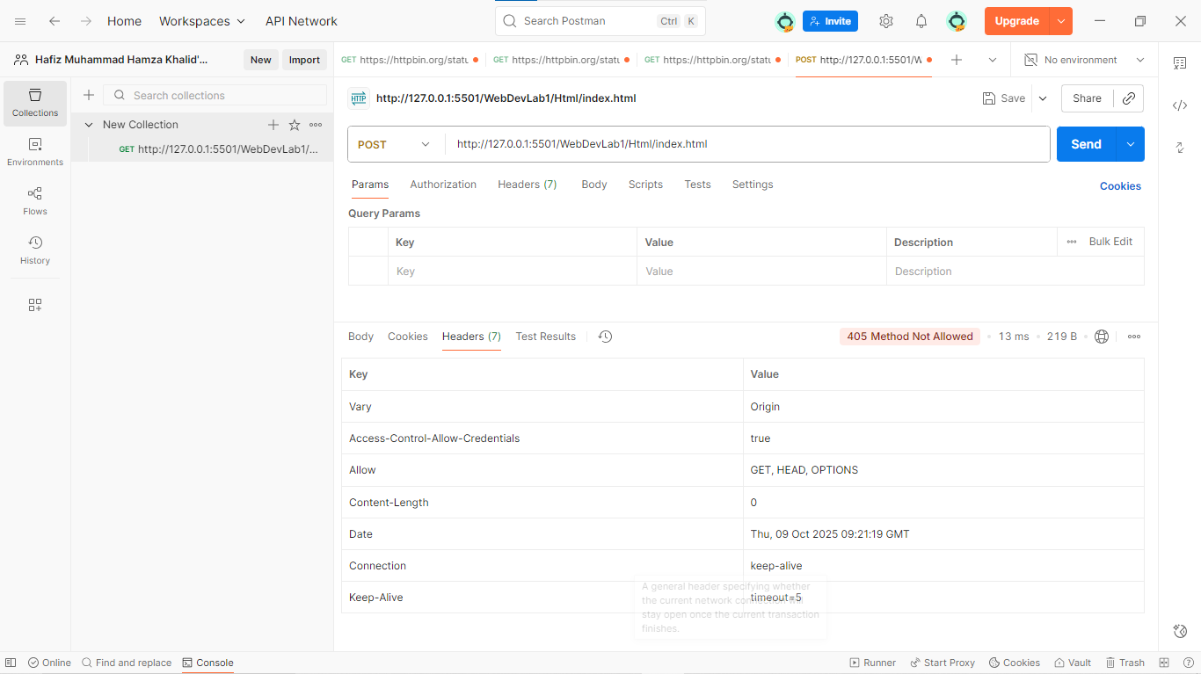

Step 3: Simulate Caching and Status Codes Modify HTML to simulate caching
1. Add meta tags to your HTML :2. 3. 4. 5. Reload the page and observe changes in response headers. Simulate Status Codes Use these test URLs:
- 200 OK: https://httpbin.org/status/200
- 301 Redirect: https://httpbin.org/status/301
- 404 Not Found: https://httpbin.org/status/404 Screenshot
- Tip: Capture each status code response in DevTools or P

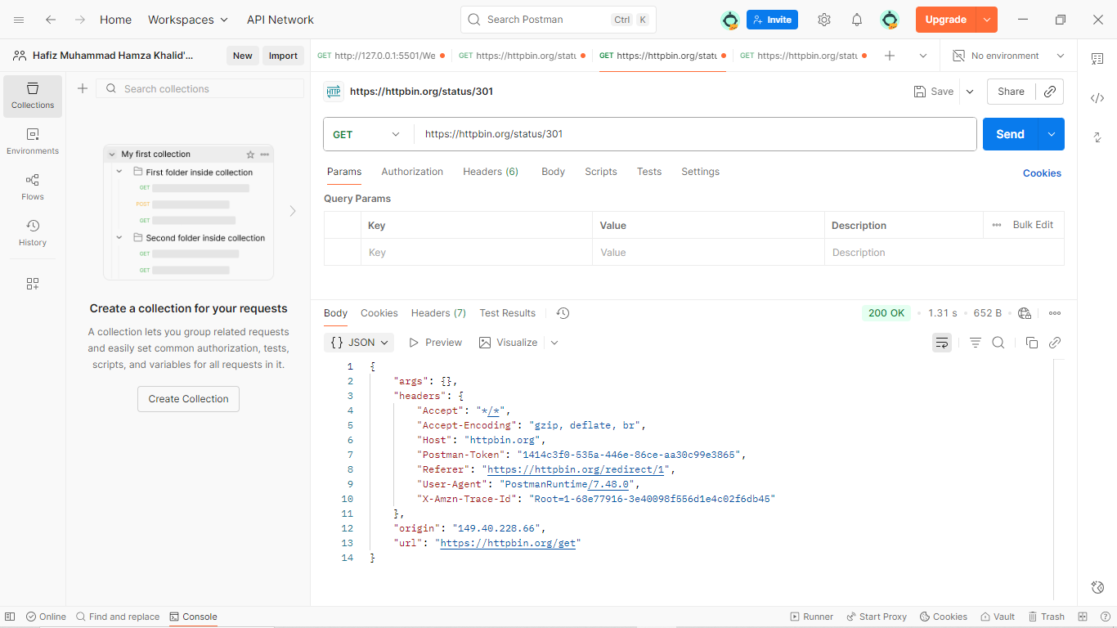
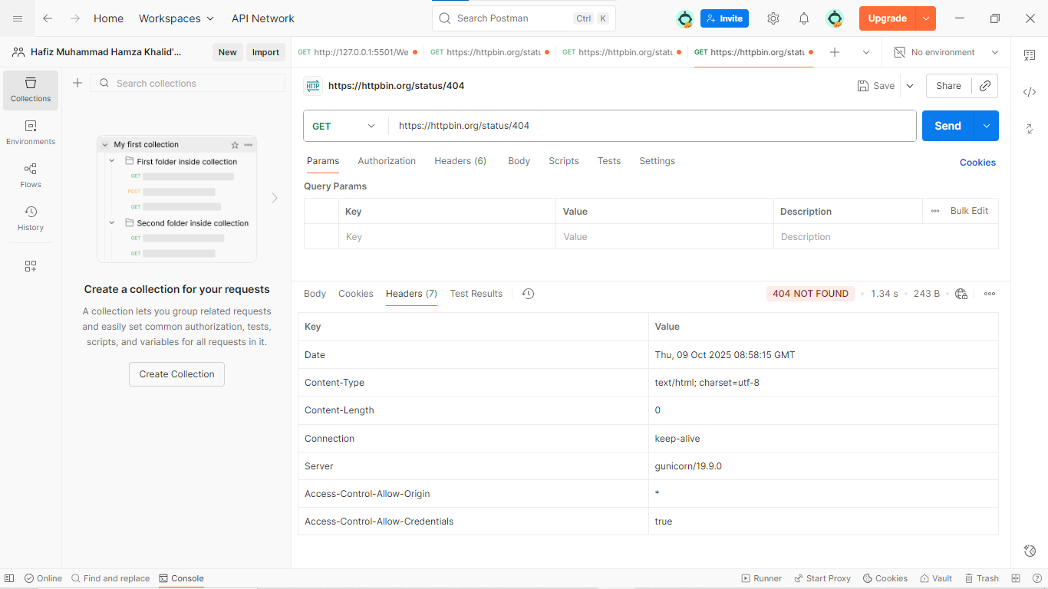

CONCLUSION:
____________________________________________________________________________________________________________________________________________________________
____________________________________________________
---------------------The End------------------------

